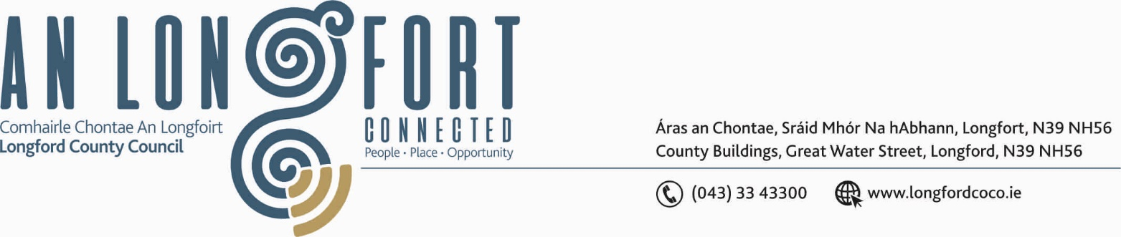

LONGFORD MUNICIPAL DISTRICT

18th October 2018.

To: Each Member of Longford Municipal District.

Dear Member,

You are requested to attend Meeting of Longford Municipal District to be held in the Council Chamber, Town Hall, Market Square, Longford, on Wednesday, 24th October 2018 at
4.00 p.m. to transact business, as set out on the Agenda hereunder.

Yours sincerely,
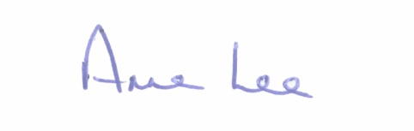

_______________
Anne Lee,
Meetings Administrator.

AGENDA

Prayer before meeting.

- Confirmation of Minutes of Longford Municipal District meeting held on the
26th September 2018 – copy enclosed.

2. Matters arising from Minutes.

- Management Report - to follow.

- Consideration of 2019-2021 Multi-Annual Restoration Improvement Programme.

- Consideration of the 2019 General Municipal Allocation.

- Consideration of location of piece of Artwork being presented by the Mayor of Noyal.

- Consideration of Free Parking arrangements during Christmas period.

- Update on Extinguishment of Right of Way at Dun Darrach.

- Notices of Motions, submitted by Councillors, as listed hereunder –

Councillor John Browne.

“I call on Longford County Council to have the trees at College Park on the Ballinalee Road and also the trees on the way out to the Ballinalee Road roundabout, pruned as appropriate.”

Councillor Joe Flaherty.

“I call on Longford Municipal Authority to honour Veronica Naughton and Marie Hand who are stepping down after twenty plus years of ceaseless commitment to and fundraising on behalf of the Irish Cancer Society. These ladies were driving forces behind the annual Daffodil Day collection in the county - a corner stone of the Cancer Society's fundraising.”

- Correspondence – enclosed

- Extract from Minutes of Joint Policing Committee Meeting held on the
10th September regarding a ban on motorised vehicles on the walkways in the Albert Reynolds Peace Park”



